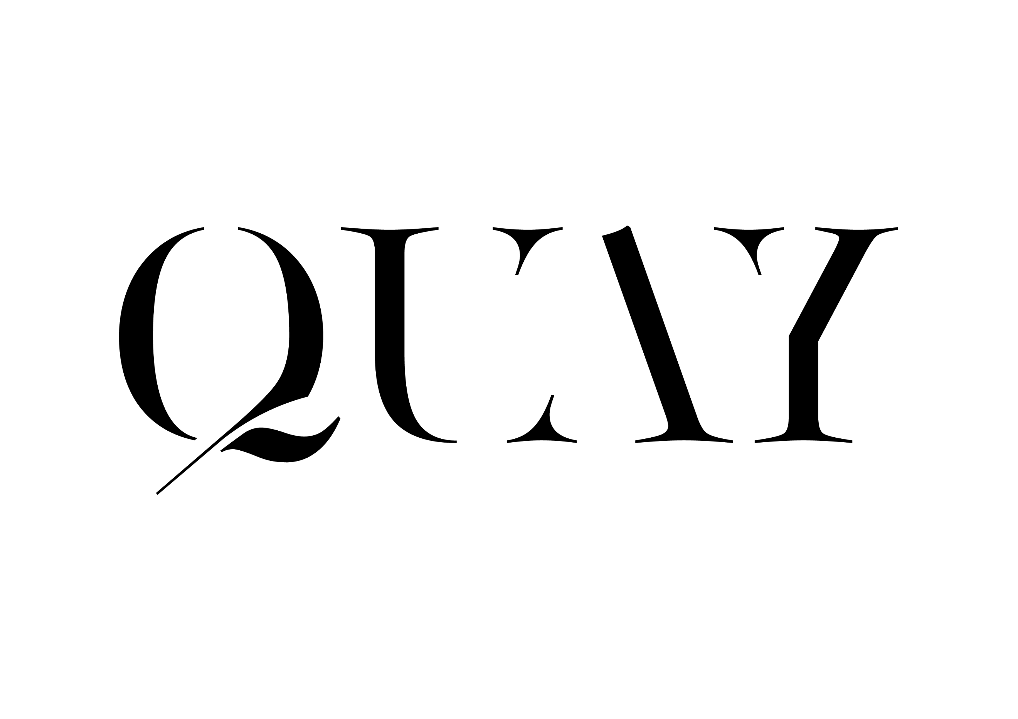

BAR MANAGER

Silvia Ali Idris

BARTENDERS

Deepesh KC

Pratik Poudel

A Sunday surcharge of 10% and Public Holiday surcharge of 12.5% will be applied to all food and beverage prices on relevant days.
MINERAL WATER

Acqua Panna 1 Litre | Tuscany, Italy 14
San Pellegrino 1 Litre | Bergamo, Lombardy Italy 14

APÉRITIFS
APÉRITIFS
Maidenii La Tonique Quinquina 17.5% | Melbourne 14
Belgrove Pommeau 17% | Kempton 14
Aperol 11% | Padua, Italy 12
Campari 25% | Milan, Italy 12
Pernod 40% | Thuir, France 12
Pampelle Ruby l’Apero 15% | Cognac, France 12
Italicus Rosolio di Bergamotto 20% | Turin, Italy 14

SAKÉ– 60ml
2020 Koueigiku Shuzo, ‘Anastasia Green’ 14% | Saga 15
Junmai Muroka Nama
2016 Naka Shuzo, ‘Asahi Wakamatsu’ 19% | Tokushima 20
Junmai Muroka Nama Genshu
2018 Miwasakura Shuzo, ‘Omusubi’ 19.7% | Hiroshima 15
Junmai Kimoto Nama Genshu
2019 Fukuchiyo Shuzo, Nabeshima 16% | Saga 17
‘Gohyakumangoku’, Junmai Ginjo Muroka
2018 Mukai Shuzo, ‘Ine Mankai’ 14.1% | Kyoto 21
Junmai Genshu
2018 Kidoizumi Shuzo, ‘Hakugyokuko’ 18% | Chiba 25
Junmai Ginjo Yamahai Muroka Nama Genshu
NV Heiwa Shuzo Tsuru-Ume Yuzushu 7.5% | Wakayama 17
NV Houraisen Kanjuku Umeshu 14% | Aichi 23

BEERS AND CIDERS
BEER & CIDER
Holgate Brewhouse Love All Pale Ale 0.5% | Woodend 12
Bridge Road Brewers Little Bling 3.4% | Beechworth 12
Sydney Beer Co. Lager 4.5% | Sydney 13
Heads of Noosa Brewing Co. Japanese Lager 4.5% | Noosaville 14

Eagle Bay Brewing Co. Pale Ale 5.1% | Margaret River 14

Moo Brew Dark Ale 5.0% | Hobart 14

Br. Verhaeghe Duchesse De Bourgogne 6.2% | West Flanders, Belgium 15

Willie Smith’s Organic Apple Cider 5.4% | Huon Valley 15
Percentage indicates alcohol by volume.

COCKTAILS AT QUAY

Maiden’s Tonic 26
Tanqueray No. Ten gin, Maidenii La Tonique Quinquina
lemon scented fino sherry, Quay bitters, blood orange soda

The Arcade 26
Ketel One vodka infused with vanilla, coconut and seasoned oak
Martell Blue Swift soaked grapes, pomegranate & spice, passionfruit

Apple Isle Fog 30
Granny smith apple infused Oates clear apple spirit, cold pressed pear pomegranate, baking spices, yuzu, apple fog

Imagine 28

Tanqueray gin, saffron, Campari, nitrogen crushed lavender
elderflower, lemon

Gabriel 28
Calle 23 blanco tequila, Zenzerino, kaffir lime, Quay ginger beer
lemongrass, fresh lime

Dusty kiss 29
Lagavulin, Pierre Huet Calvados, Naked Hazelnut, cacao
Cassis & red wine reduction

TEMPERANCE
Garden & Tonic 18
Seedlip Garden, elderflower & tonic reduction, lemon oil, green apple

Lemongrass & Ginger 18
Lyre’s absinthe, lemongrass syrup, mint, ginger, granny apple smith

Grape & Passionfruit 18
Cold pressed grapes, passionfruit, rosemary two

Consommé & Dashi 18
Clarified tomato consommé, ponzu, ginger

Honey & Grapefruit 18
Seedlip Spice, Yellow Box honey, blood orange soda

QQQQ Gin by Four Pillars

Peter Gilmore and Bar Manager Taka Shino have teamed up with Yarra Valley distillery Four Pillars to create a distinctly Australian gin.

Juniper is a staple found in all gins, along with home-grown botanicals lemon leaves, fennel, strawberry gum, bee pollen, cinnamon myrtle, desert lime, grains of paradise, meadowsweet and mandarin.

We encourage you to try it in one of the below classic styles:

QQQQ Gin & Tonic 18

Served with Strangelove light tonic, lemons and bee pollen

QQQQ Gin Martini 26
Served with Oscar 697 extra dry vermouth, lemon twist and
mandarin mist

QQQQ Barrel Negroni 26
Four Q Gin rested in our Four Pillars barrel, together with Campari
Carpano rosso vermouth and Carpano Antica Formula vermouth

GIN

Ester Dry gin 43% | Sydney 16
QQQQ by Four Pillars 44.8% | Healesville 18
Reed & Co Remedy 44% | Bright 17
KIS O’gin 43.5% | Kangaroo Island 17
Poltergeist Unfiltered 46% | Hobart 17
Farmer’s Wife Autumn Dry 48% | Allworth 18
Never Never Distilling Co. Southern Strength 52% | Adelaide 19

Tanqueray 40% | Edinburgh, Scotland 13
Tanqueray No. Ten 47.3% | Edinburgh, Scotland 18
Hendrick’s 41.4% | Glasgow, Scotland 18
Hernö Old Tom 43% | Härnösand, Sweden 18
Amazonian Gin 41% | Lima, Peru 18

VODKA

OCD Lemon Drop 44% | Sydney 16

Ketel One 40% | Schiedam, Holland 13
Ciroc 40% | Cognac, France 17
Grey Goose 40% | Cognac, France 18
Belvedere Pure 40% | Żyrardów, Poland 18

TEQUILA

Don Julio Blanco 38% | Jalisco, Mexico 15
Calle 23 Blanco 40% | Jalisco, Mexico 15
Fortaleza Reposado 40% | Jalisco, Mexico 20
Ocho Single Barrel Extra Añejo 54.2% | Jalisco, Mexico 46

MEZCAL

Del Maguey Chichicapa 46% | Oaxaca, Mexico 15

Percentage indicates alcohol by volume.
WHISKY/WHISKEY
BLENDED AND SINGLE MALTS
Otter Craft Distilling No. 1 Port Cask 56.3% | Sydney 59
Otter Craft Distilling No. 2 French Cask 49.7% | Sydney 30
Blackgate Single Cask 50% | Mendooran 52
Boatrocker Forget Me Not 50% | Melbourne 34
Bakery Hill Classic Cask 59% | Ballarat 48
Lark Distillery Classic Cask 43% | Hobart 35
Lark Distillery Cask Strength 58% | Hobart 41
Sullivans Cove Distillery 47.4% | Hobart 63
Limited Edition Double Cask DC100
Sullivans Cove Distillery 47.5% | Hobart 130
Old & Rare 17yo American Oak HH0207

Johnnie Walker Black Label 40% | Edinburgh, Scotland 14
Johnnie Walker Blue 40% | Edinburgh, Scotland 29
Glenkinchie Distillers Edition 43% | Lowlands, Scotland 26
Cragganmore 12yo 40% | Speyside, Scotland 16
The Macallan 18yo Sherry Oak Cask 43% | Speyside, Scotland 75
Dalwhinnie Distillers Edition 43% | Highlands, Scotland 29
Oban 14yo 43% | West Coast Highlands, Scotland 18
Lagavulin 16yo 43% | Islay, Scotland 20
Laphroaig Quarter Cask 48% | Islay, Scotland 24
Gordon Macphail Port Ellen 1980 46% | Islay, Scotland 310
Talisker 25yo 45.8% | Isle of Skye, Scotland 70
Talisker 40yo Bodega Series 50% | Isle of Skye, Scotland 485
Hibiki 17yo 43% | Aichi, Japan 165
Hibiki 21yo 43% | Aichi, Japan 185
Mars Maltage Cosmo 43% | Nagano, Japan 30
Ichiro’s Malt MWR 46% | Saitama, Japan 41
Ichiro’s Malt & Grain Limited Edition 48% | Saitama, Japan 53
Yamazaki 18yo 43% | Osaka, Japan 190
Kinahans 10yo 46% | Dublin, Ireland 24
Jameson 18yo 40% | County Cork, Ireland 42

AMERICAN
Woodford Reserve 40% | Kentucky 14
Elijah Craig Small Batch 47% | Kentucky 19
Koval Bourbon 47% | Chicago 23
Bulleit Rye 45% | Kentucky 14
Michter’s Single Barrel Rye 42.4% | Kentucky 23
Whistlepig Rye 15yo 46% | Vermont 46
George Dickel No. 12 45% | Tennessee 14
Percentage indicates alcohol by volume.
LOUIS XIII by REMY MARTIN

Louis XIII is a cognac without peer. An idea born in 1874, created with the greatest and the oldest eau de vie in Rémy Martin’s cellars. Produced exclusively from grapes grown in the Grande Champagne region, generations of cellar masters have lay down their own spirit to age in private vaults in anticipation of the next century.

We are proud to offer this incredible spirit in two measurements

15ml 210
30ml 420
BRANDY

Martell Blue Swift 40% | Cognac, France 15
Hennessy XO 40% | Cognac, France 40
Renier XO Grande 40% | Cognac, France 40
Raymond Ragnaud 1992 41% | Cognac, France 64
Jean Grosperrin 1988 49.5% |Cognac, France 55

Chateau de Laubade 1979 46.2% | Armagnac, France 50

Delord 1984 40% | Bas-Armagnac, France 26

Grosset 45 Riesling Spirit 45% | Clare Valley 19
2000 Marc de Bourgogne
Domaine de la Romanée-Conti 45%| Burgundy, France 60

Victor Gontier 2003 Calvados 40% | Domfrontais, France 35

Pisco Del Parral Acholado 42% | Lima, Peru 18

RUM

Bundaberg MDC Small Batch 40% | Bundaberg 15
Bundaberg Solera MDC 40% | Bundaberg 39
Husk Spiced Bam Bam 40% | Tumbulgum 19

Santa Teresa 1796 40% | Aragua, Venezuela 16
Flor de Caña 18yo Centenario 40% | Chichigalpa, Nicaragua 28
Ron Zacapa 23 Centenario 40% | Zacapa, Guatemala 20
Ron Zacapa XO 40% | Zacapa, Guatemala 39
Black Tears dry Spiced 40% | Cuba 16

Percentage indicates alcohol by volume

DIGESTIVE & LIQUEUR

Mac by Brookie’s 23% | Byron Bay 13

Native Bush Limoncello 31.4% | Sydney 14
Mr. Black Coffee 25% | Erina 14
Marionette Peach 25% | Melbourne 14
White Possum Naked Hazelnut 24% | Melbourne 14
KIS Zenzerino 33% | Kangaroo Island 15
Underground Spirits Caramel Vodka 40% | Canberra 18

Amaro Montenegro 23% | Bologna, Italy 14
Fernet Branca 39% | Milan, Italy 14
Varnelli Anice Secco Speciale Mistra 46% | Marche, Italy 15

Chartreuse Yellow 40% | Voiron, France 16
Chartreuse Green 55% | Voiron, France 18

Bepi Tosolini Amaretto Veneziano Salizá 28% | Friuli, Italy 16

Hoshiko Original Ume 2016 20% | Wakayama, Japan 16

SHERRY – 60ml

Luis Pérez, Fino Caberrubia NV 16% | Pago Carrascal 16
Equipo Navazos 15% | Sanlúcar de Barrameda 9
Think Manzanilla En Rama D.O.
Equipo Navazos 16.5% | Sanlúcar de Barrameda 45
59 La Bota Manzanilla Pasada D.O.
Toro Albalá 21% | Montilla-Moriles 17
Marqués de Poley Amontillado Viejísimo D.O

Percentage indicates alcohol by volume.

